**Jason 2/ALTIKA Add-in Tool**

**Steps to install the Altimetry Toolkit** (Require ArcMap and Windows PC):

1. Run the JASON2_Script.exe and follow the on-screen instruction. FYI: This will download the required matlab compiler and install the script. This may take 5-10min depending upon the download speed.
2. Run the Altika_Script.exe and follow the on-screen instruction. Since the required matlab compiler is already installed in the above step, this should take few seconds or a minute to complete.
3. Extract the zip file "Altimetry_Toolkit" and move it to the "C:\" root directory. (Note: There should be 4 folders and one mxd file in C:\Altimetry_Toolkit)

Note: the Add-in tool has been created using ArcGIS version 10.2 if using different ArcGIS version do the following:

* 1. Open “config.xml” located in C:/Altimetry_Toolkit/Template (open as notepad/wordpad) and change the version number
  2. Modified the version as follows:

<Targets>

<Target name="Desktop" version="10.2" />

</Targets

1. Go to C:\Altimetry_Toolkit\Template\ folder, doubleclicking the Template.esriaddin file to install the toolkit. Follow the on-screen instruction. ArcMap should not be open while doing this.

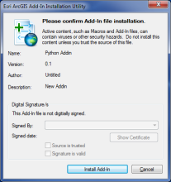 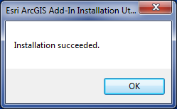

1. Open the ArcMap file by double clicking Jason_SARAL_Groundtrack.mxd located in "C:\Altimetry_Toolkit\"
2. The Add-in should open automatically when the Jason_SARAL_Groundtrack.mxd is opened and is called Toolbar. It should look as follows:

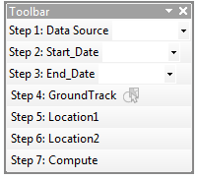

1. If the tool does not show up automatically check step 3. In addition, on the standard toolbar, click Customize > Customized Mode
   1. In the Customized window and Toolbars tab make sure “Toolbar” is selected. “Toolbar” is the name of the add-in tool.



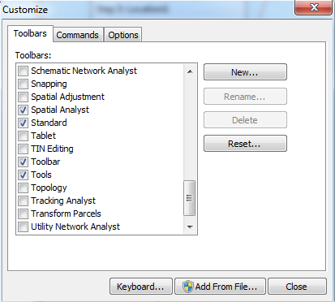

* 1. The tool should also be available to add to ArcMap by righ-clicking in the standard toolbar gray area and selecting “Toolbar”.

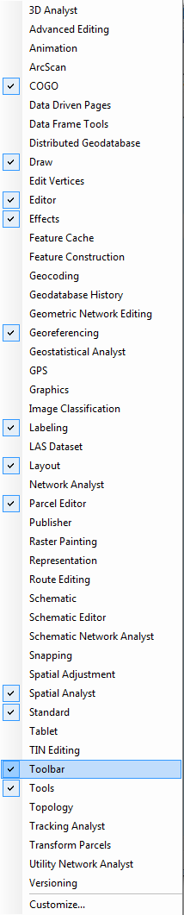

The mxd file should have: (1) Toolbar added in, (2) A table of contents with the following: the ground track layers for Jason 2 and SARAL, and a basemap.

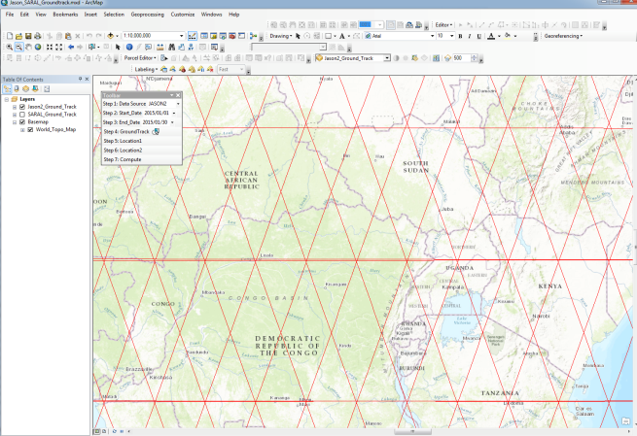

**Using** Jason 2/SARAL **Toolbar**

1. Follow the order of the Steps provided in the tool:
   1. Step 1: Select Altimetry Data Source: (JASON 2 or ALTIKA).

Note: Once you select a data source, appropriate ground track will be displayed (Jason2 ground track in red or ALTIKA in black color).

* 1. Step 2 and 3: Select start and end date using YYYY/MM/DD format.

Note: Once you select the data source in Step1, start and end date will be automatically populated based on the selected satellite date range available. Modify the start and end date to your need, as this will affect the download time.

* 1. Step 4: Select the ground track: Zoom in to the water body of your interest where there is ground track overlay (the width to select should be of at least 600 m) and using the ground track selection tool (see below image) click and select the track (selected track will be highlighted in turquoise color).

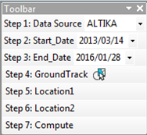 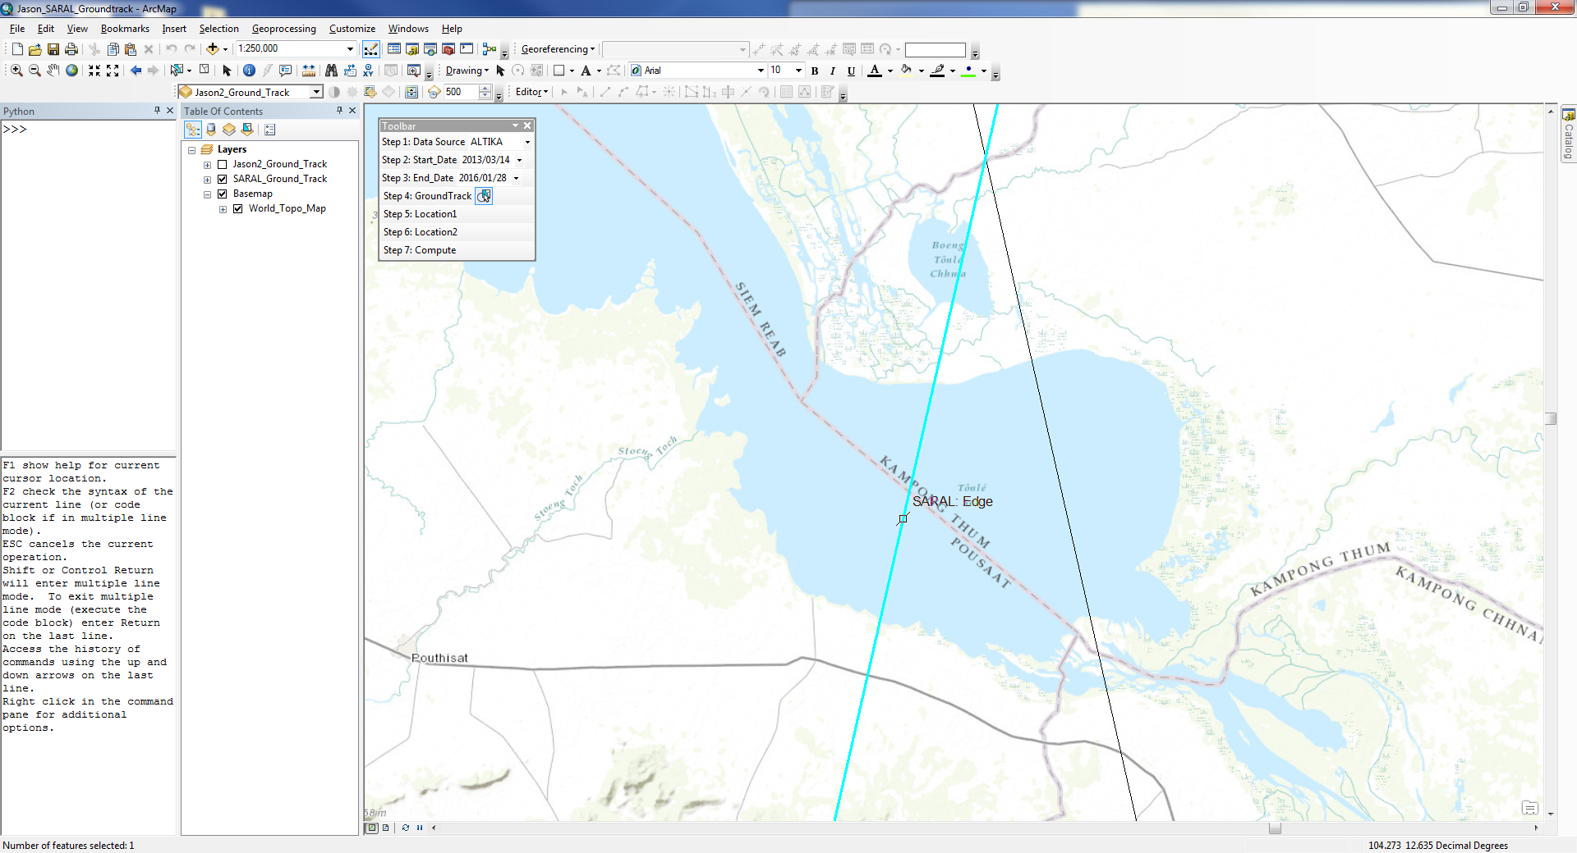

* 1. Step 5 and 6: Once the track has been selected, the next step is to indicate the lower and upper location of the track that overlap with the waterbody (river or lake).
     1. Step 5: Location 1 = should be the lower latitude. Just click on the step and then click on the track selected
     2. Step 6: Location 2 = should be the upper latitude.

*Note: An updated version of the tool will work independently of the order in which the locations are selected.*

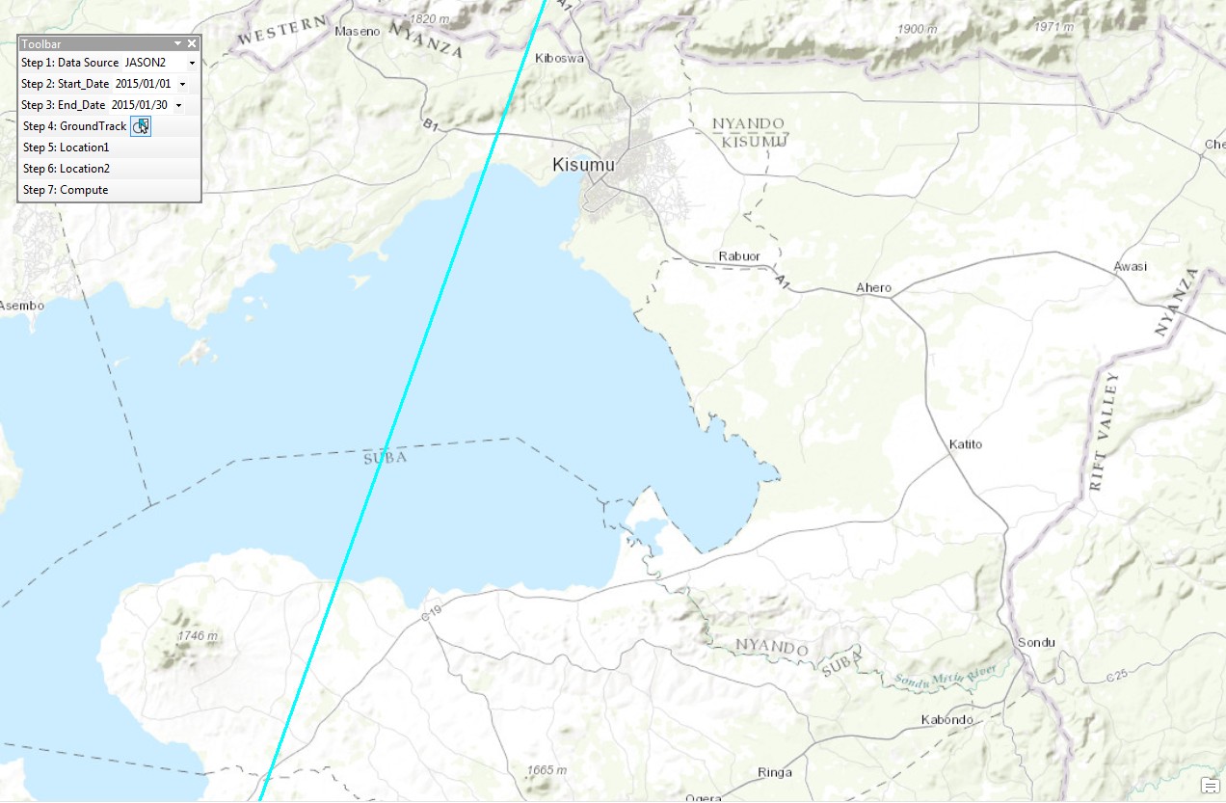

Location 1

Location 2

* 1. Step 7: Compute

The tool will download the altimetry data (either Jason 2 or ALTIKA ground track data for the time period selected to *C:\Altimetry_Toolkit\JASON2\Data* and *C:\Altimetry_Toolkit\SARAL\Data* respectively) and process it for the portion of the track selected. Then a plot with the results is shown. Examples below:

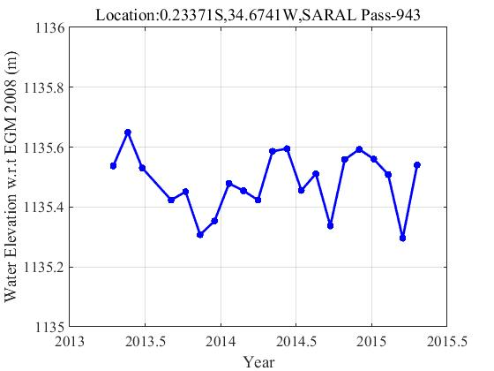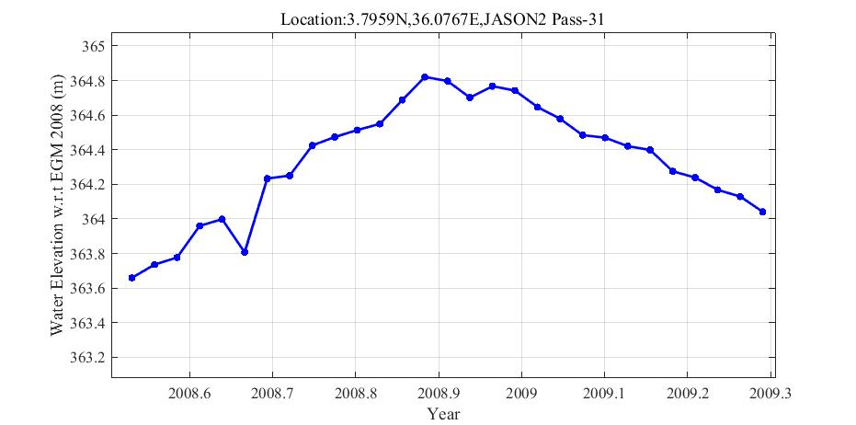

The original information that is used to create the plot will be also saved as a .csv file in *C:\Altimetry_Toolkit\JASON2\Data or C:\Altimetry_Toolkit\SARAL\Data* (depending of the satellite selected). The graph will also be saved there as a .png file. Filename of both (.csv and .png) represents the location (coordinate) of the track-section selected.

**Troubleshooting tip**: In Step 7, when you click compute, it should take few minutes to download the data from ftp. For example (Jason2 data), After clicking compute button in Step 7, Go to C:\Altimetry_Toolkit\JASON\Data, you should see the data file with naming convention for your selected date range JA2_GPN_2PdP222_120_20140717_012350_20140717_022003.nc

If you do not see the data file, open the python window in ArcMap and write the following:

>>> import arcpy

*Then continue using the tool. The coordinates (x,y) will be shown in the python window once they are selected in the following tool step. Other progress messages can also be seen in the python window:*

